**Project 8:**

**VPC Peering**

Task 1: Create 2 VPCs

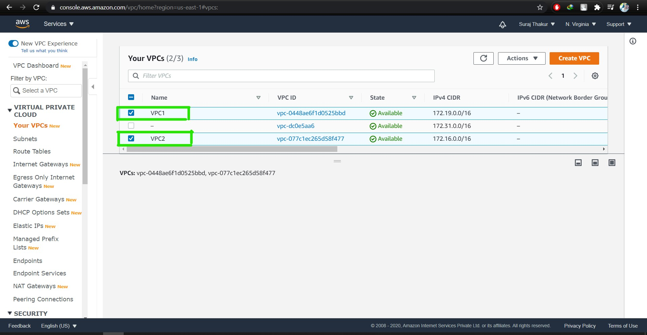

Task 2: Create Internet Gateways for both the VPCs

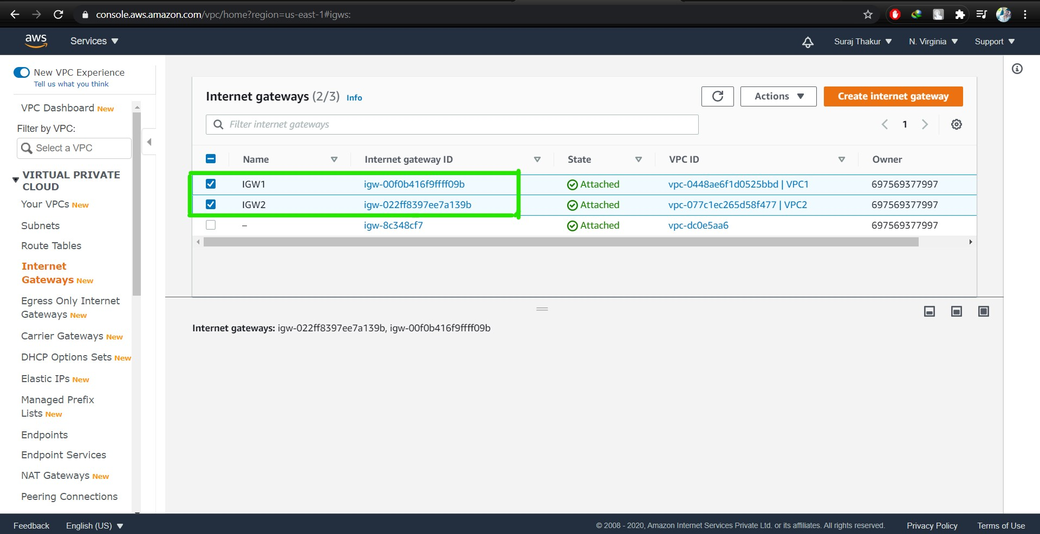

Task 3: Create Route Tables for both the VPCs

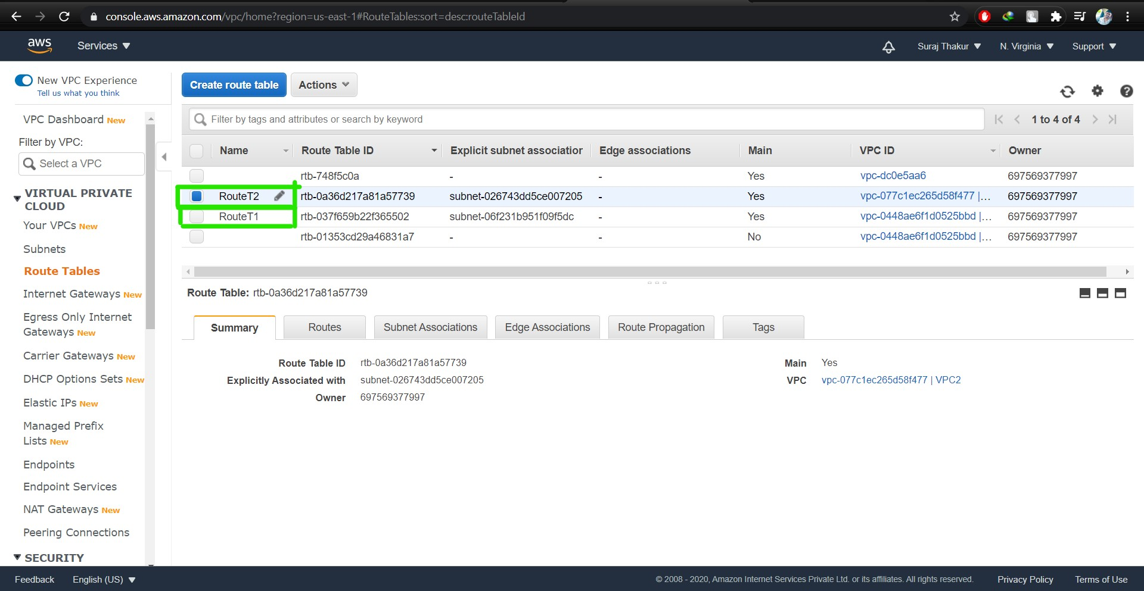

Task 4: Edit Route table Routes; insert the IPv4 of second VPC in Route table 1 and vice versa.

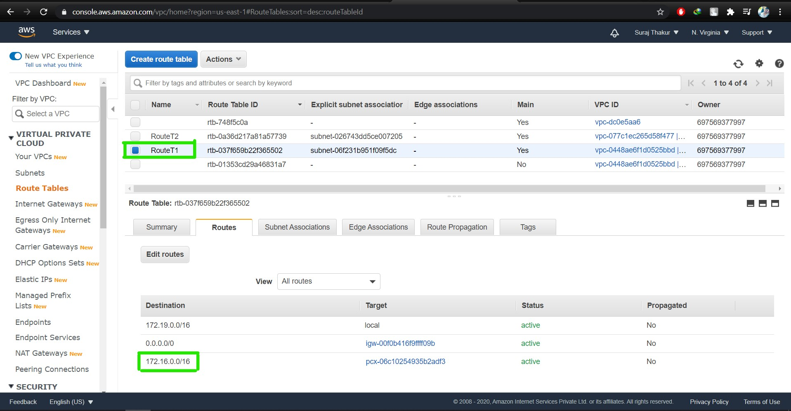

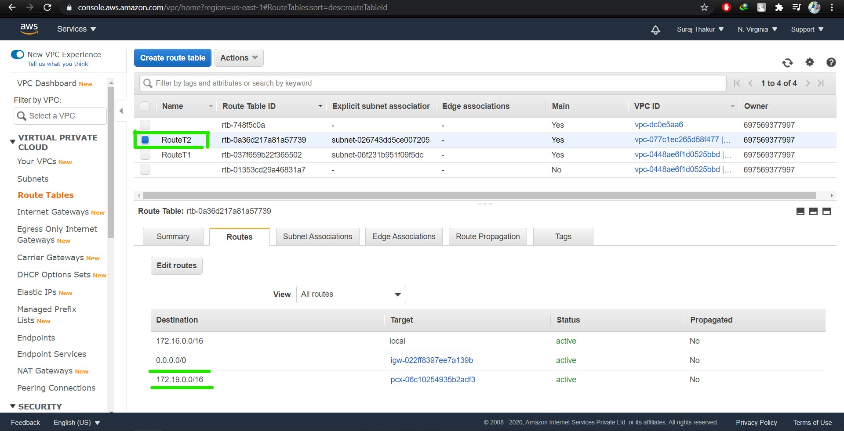

Task 5: Create Subnets

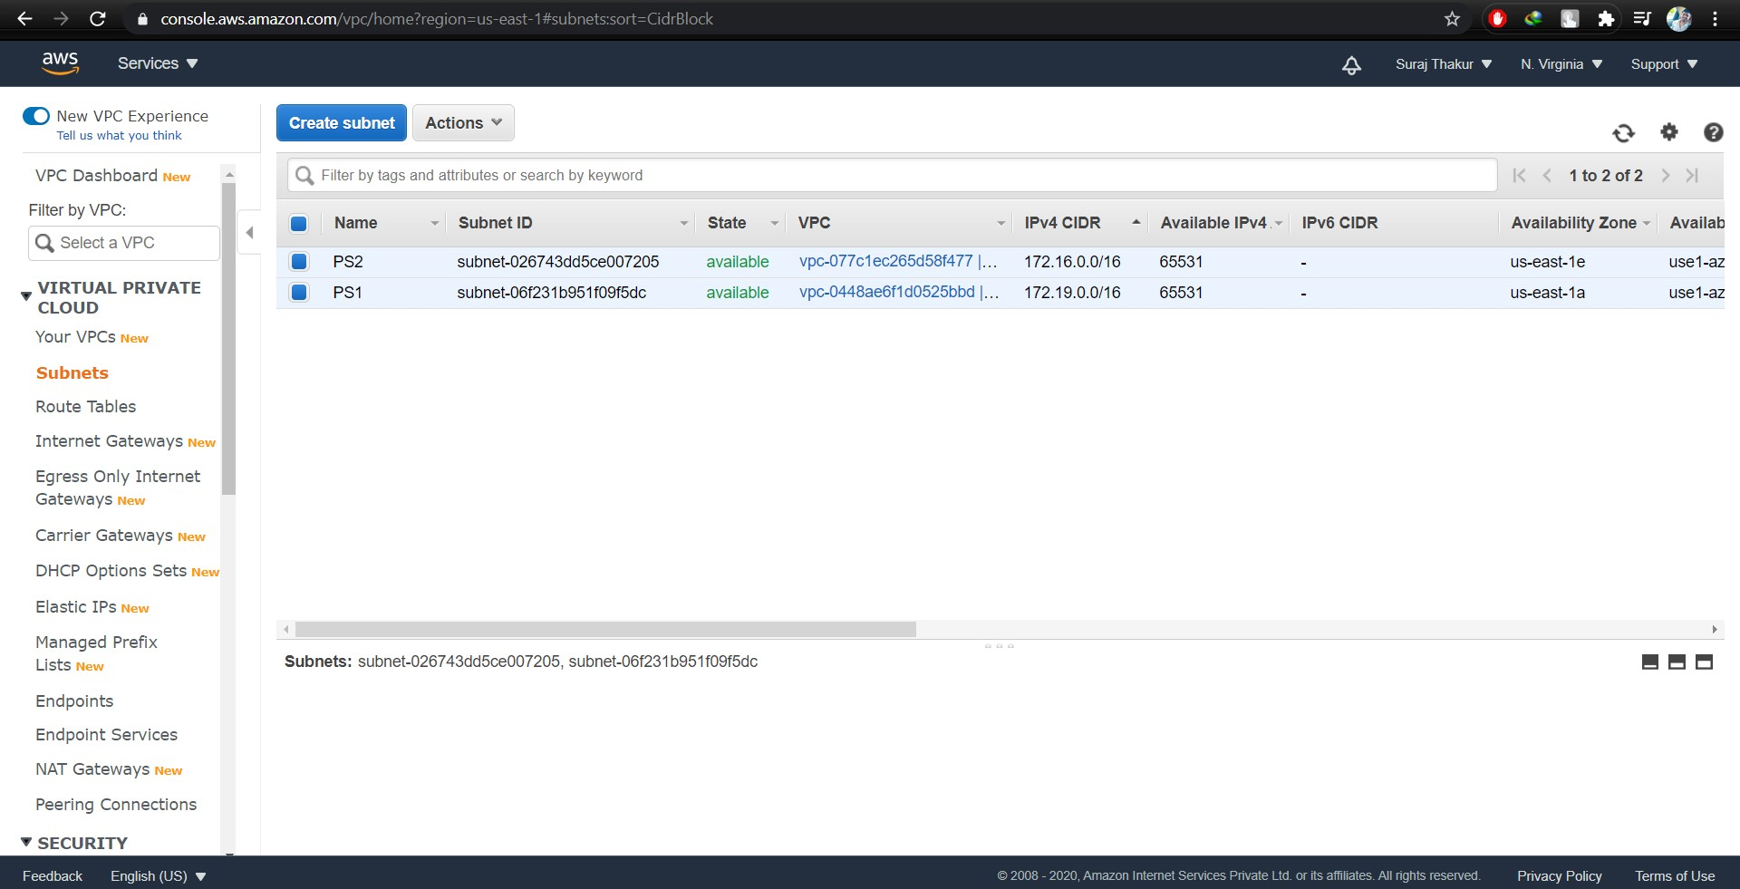

Task 6: Ping the Public Ip address of the Instance; it should successfully ping and while pinging private IP address it should give an error: request time out.

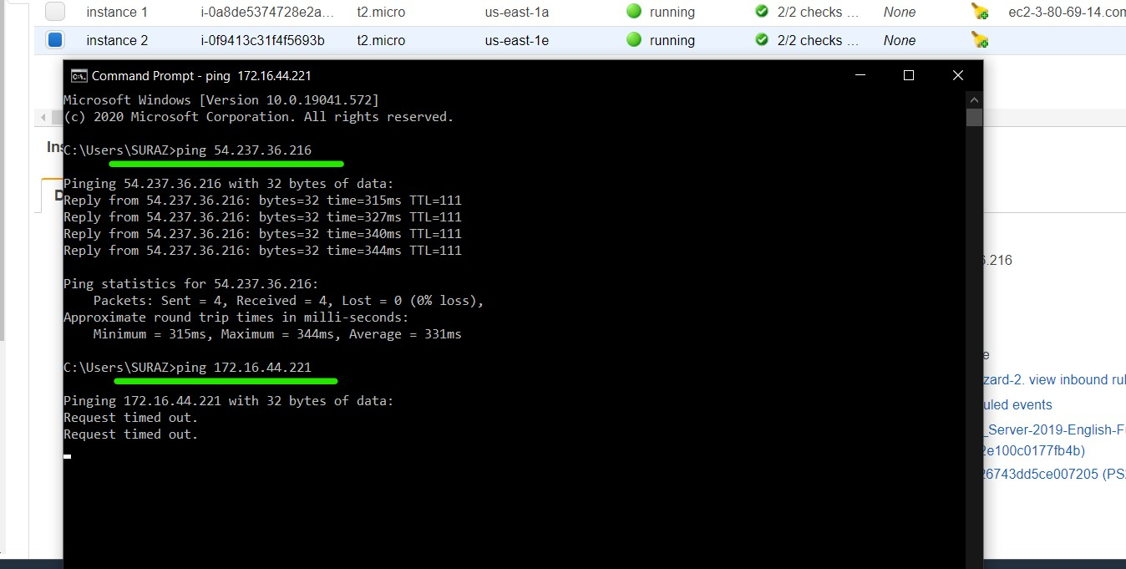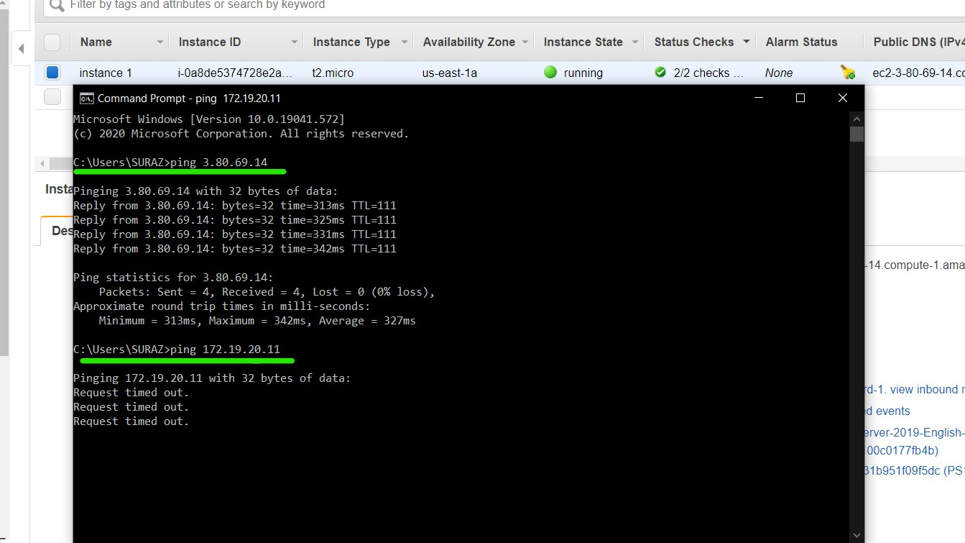

Task 7: Create Peering Connection using both the VPCs. One VPC as Requester and another VPC as Accepter

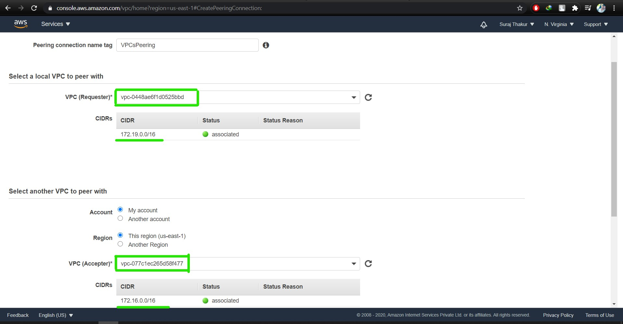

Task 8: After creating peering connection, ping the Private IP address and it must be successful.

